Test Results

Contents

Unit Tests 2

Integration Tests 3

End-to-End Testing 3

User Acceptance Testing 3

# Unit Tests

The application will have a unit test coverage of at least 80% and user interfaces will be tested and signed off by users. For a more detailed breakdown of the unit test coverage see the index.html in the htmlcov folder accompanying this document.

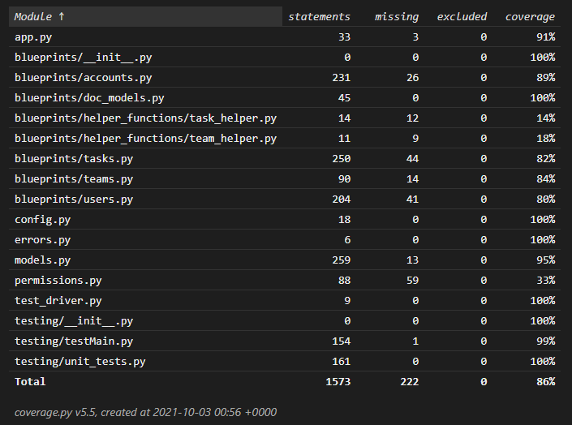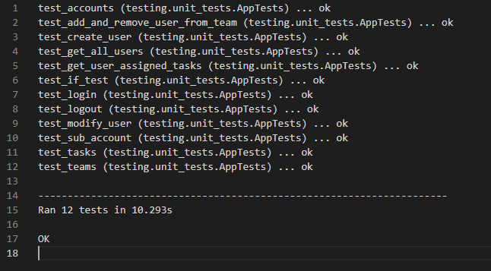

# Integration Tests

Integration tests were performed as features were developed. During these tests a demonstration was given to the product owner and or other parties, then users were asked to try the new features and give feedback on their experience with the project. The users were excited through the entire process and after the initial design getting negative feedback was difficult because the users did not want to delay project delivery. Some minor formatting changes were made because of the tests, but no fundamental problems were discovered.

# End-to-End Testing

At the conclusion of project development, the developer met with the project owner and the developer and project owner conducted an end-to-end test of the project going through every feature in the completed project and validating that the project owner was happy with the project. No issues were discovered during this phase of testing and due to the ongoing nature of communication on the project the project owner was happy with the presentation of the project.

# User Acceptance Testing

The last phase of testing was for the entire user team to get a chance to interact with the application and validate that they were able to use the application. Most users had already experienced all or part of the application so training the users on the application was very quick and they were able to quickly validate the applications functionality. The users were pleased with the new tool that they were provided.